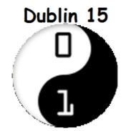 WEEK 3

## Making a separate CSS file instead of using <style> tags

* Open a new file in Notepad++ and save it as styles.css. Remember to have the CSS file and the HTML file in the same folder.
* Open your HTML file highlight all the code between the <style> tags
* Right-Click and cut the highlighted text and Paste it into your styles.css file

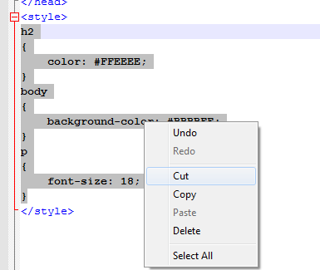

You can now delete the <style> tags

## Linking a CSS file to our HTML file using the <link> tag.

This ***must*** be placed within the <head> tags. You’ll notice the name of the CSS file follows (in quotes) the href= part. This should be the same as whatever name you called your CSS file.

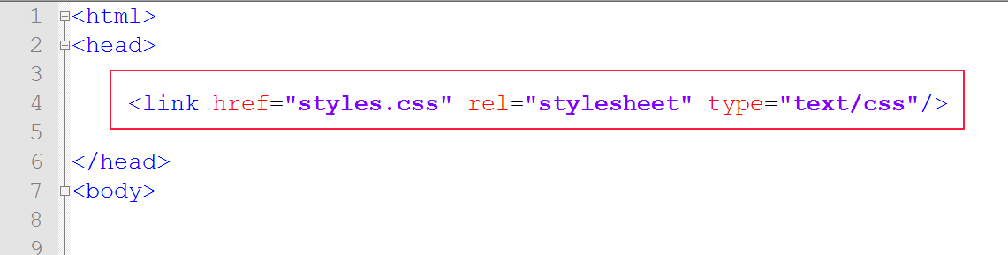

Save all your files and test your html page by opening it up. You can change the background-color of the body tags in the CSS file to check.

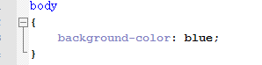

## Elements

We call a pair of tags (opening and closing) an element of a html page. E.g.

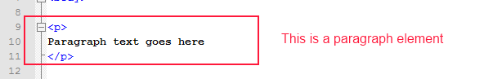

## Parent and Child

An element is said to be a child of another element (the parent) when it is completely contained within. If another element is contained within the parent, but not within the child; it is a sibling to the child and also a child to the parent element. A child element is only concerned with the properties of its parent and its siblings, such as width/height/position etc.

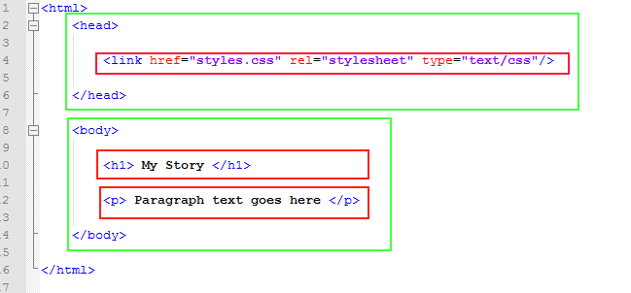

In the above example, the <h1> element and the <p> element are both siblings to each other **and children to the <body>element. The <link> element is a child to the <head> element. The <head> and <body> elements are both siblings to each other. Can you tell what element the <head> and <body> are children to?**

## Block vs Inline elements

Tags in html can be split into different categories. Two of the main types will look at are Block and Inline.

Block elements act like structural elements. When you use a block element ( such as <p> or <h1> ) , if you don’t set a width for a block element then it will expand to fill its parent container. If we do not set a height, it will expand vertically to fit all it’s children elements. By default (although this can be changed) a block element will be placed below previous elements.

Inline elements on the other hand flow along with text content. They will not drop below other elements like block elements. They will ignore width and height properties. The easiest way to think of inline elements are elements that act like text. Examples we have seen so far are <a>, <em> and <strong>.

Note: You can place a block element and/or an inline element within another block element. However, you cannot put a block element within an inline element. There is one exception; the <a> tag, which can be wrapped around most elements.

This idea of block vs inline and parent and child will become more important when we start to layout our web site design using the <div> tag next week.

## Attributes

An attribute gives us additional information about a tag. We have already used attributes such as an image source or an anchors link reference. Attributes are always provided in the opening tag. Attributes can also be used to apply information we provide about a tag in our CSS file.



## Tag names, id & classes

So far we have used tag names to apply colour, font type and background colour to parts of our web page. However, because we use the same tags a lot in our webpage we need to be able to pick different parts of our page out to so we can style them differently. To do this we will introduce two more methods. Id’s and classes.

An id is a name you create in your CSS file with a # before it. To apply it to a tag we add it to our tag in the HTML file as an id attribute with the name in quotes like below.

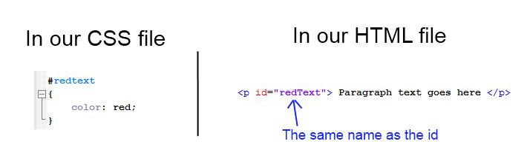

A class is done in a similar way. Instead of the attribute named as id, we use class in our HTML file. Instead of using a # in our CSS, we use a full stop.

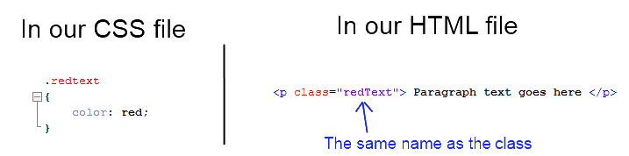

So when do we use a class and when do we use an id attribute? An id is used only once. In other words, if there’s only one unique part of our page we want to change, then we should use an id. If we want to change multiple areas of our page and reuse the same style, we should use a class.